**Steps to deploy war file in tomcat**

**METHOD 1:**

Copy the war file under the webapps folder at tomcat installation directory as shown below:

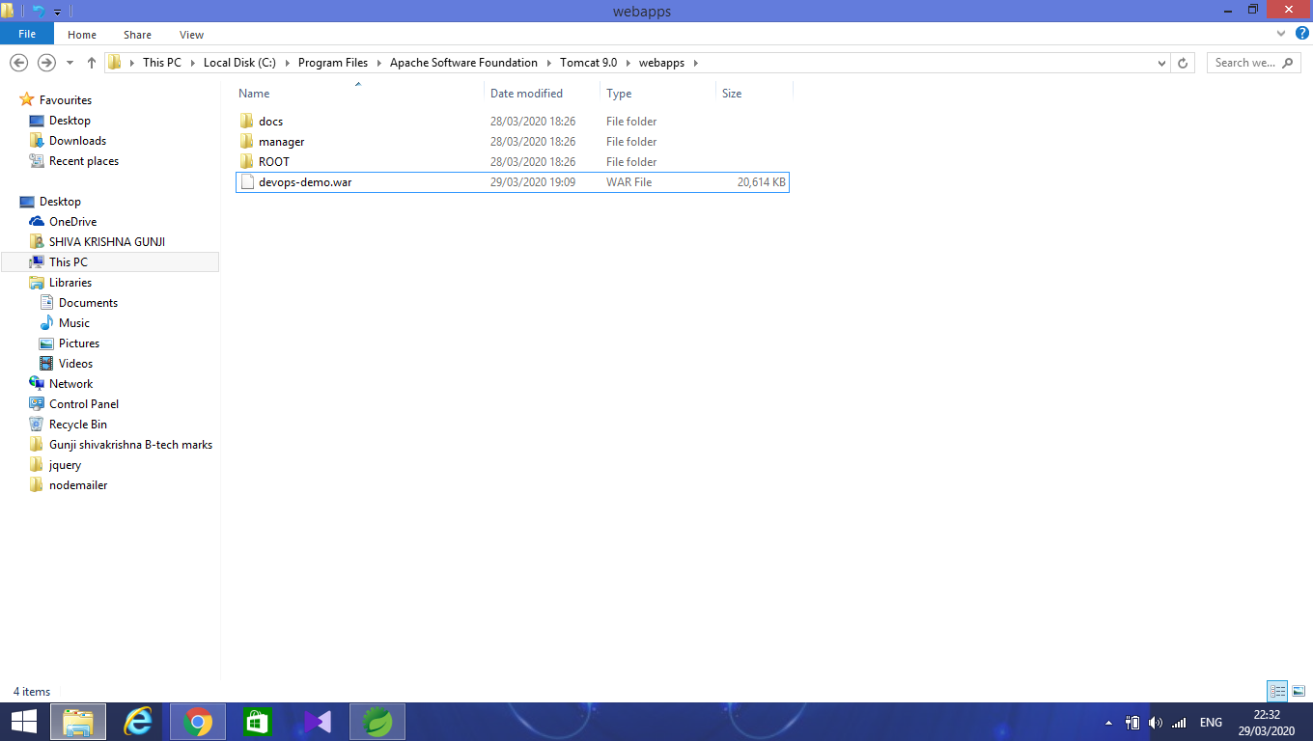

Next, goto the bin folder and type **cmd** in the search bar and hit enter.

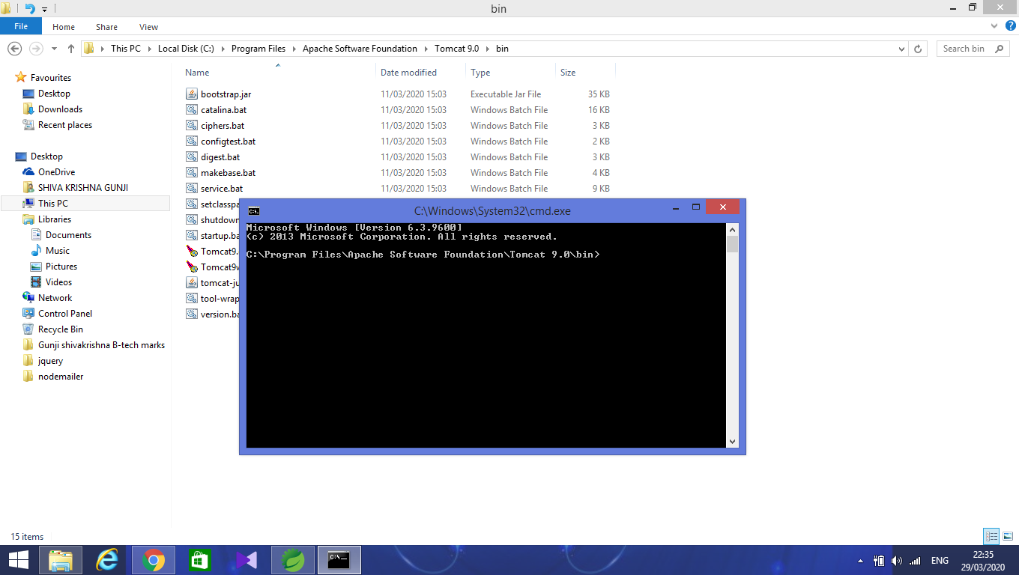

Next, in cmd enter startup.bat and hit enter.

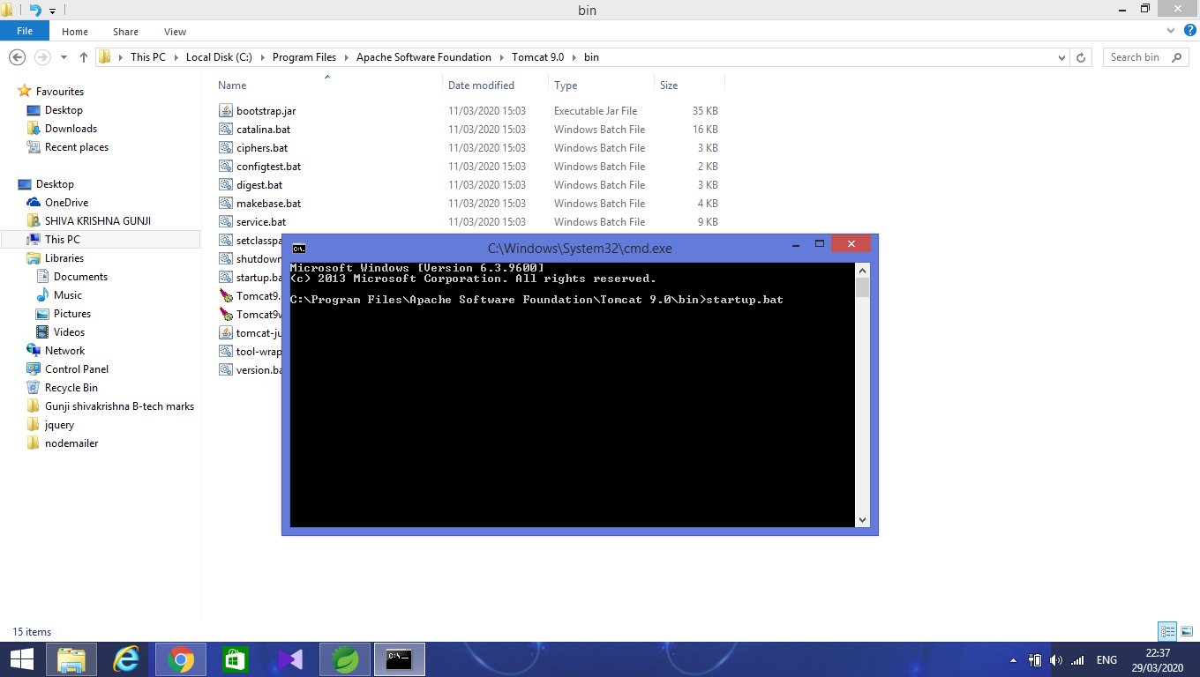

Now, the tomcat server will start at default port as shown below

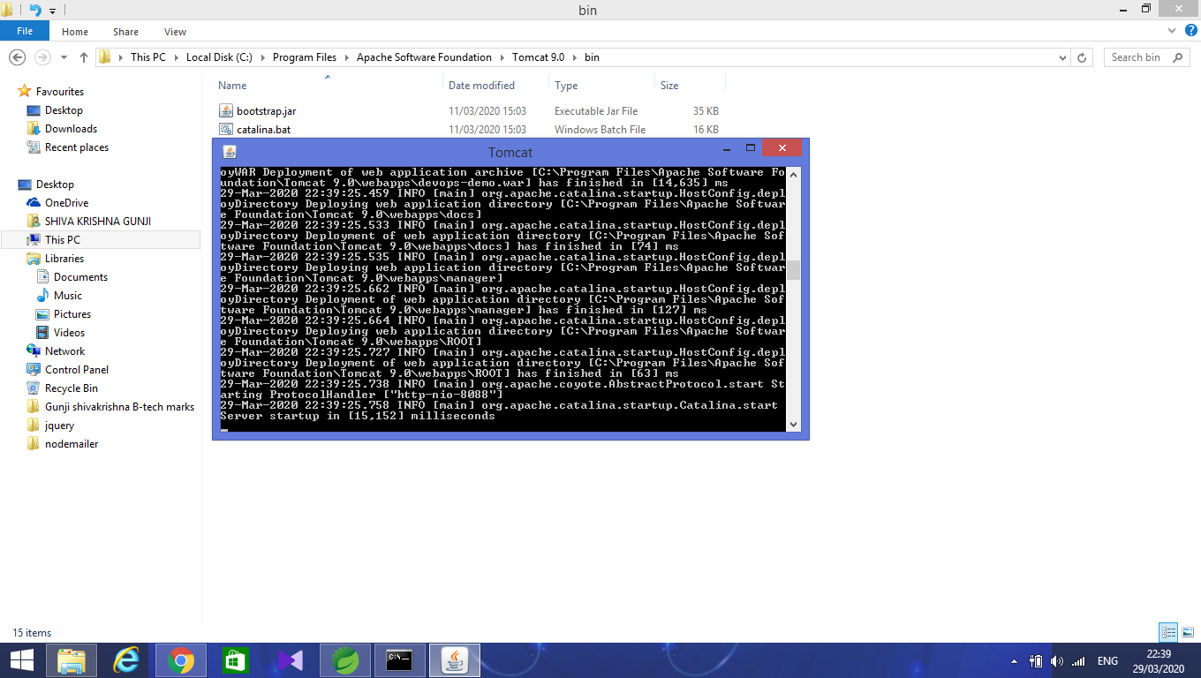

In the chrome enter the url as <http://localhost>:<port number>/<war file name> and hit enter jsp(home) page will be displayed.

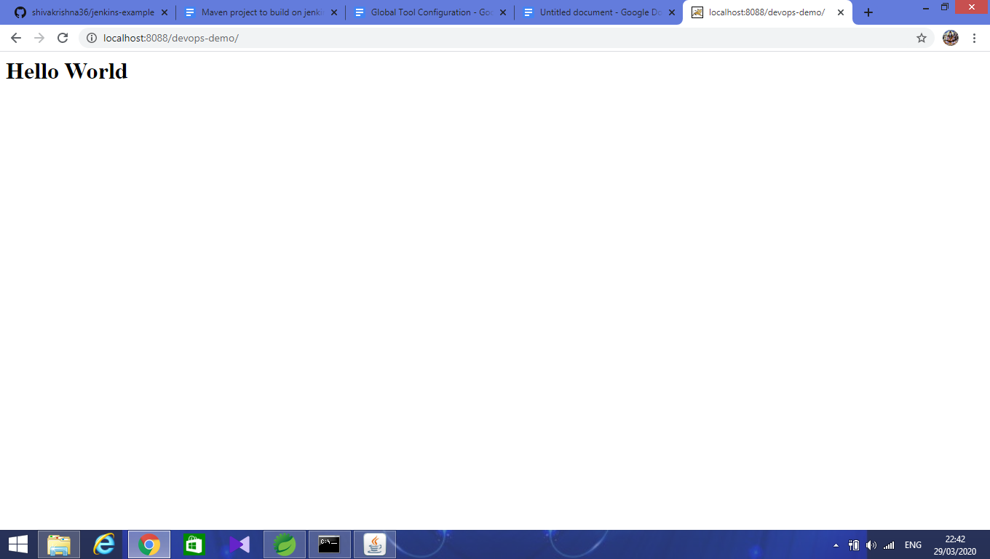

METHOD 2:

Run the tomcat server and goto default page of tomcat.

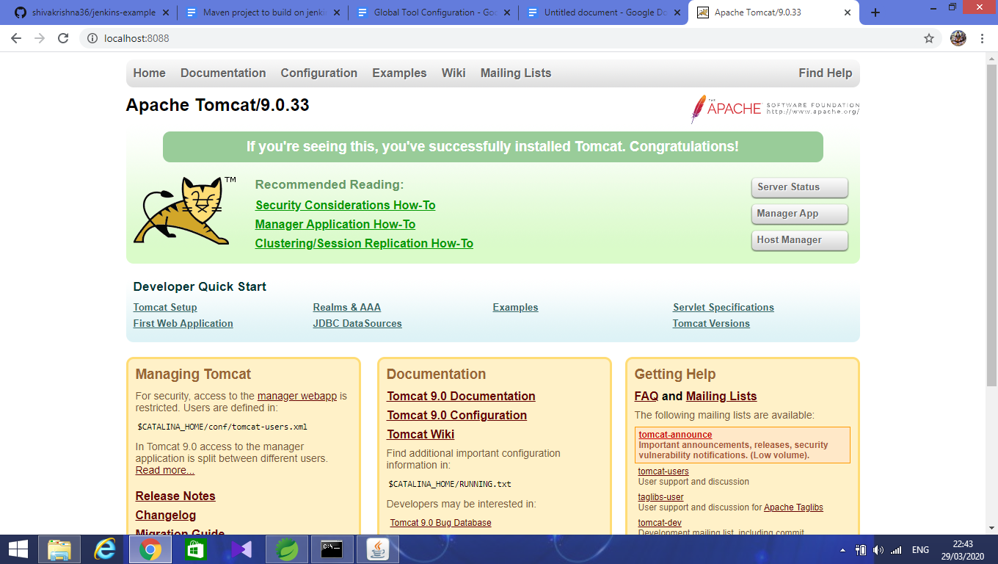

Click on **manager App** which is at top right second option.

Enter **username** and **password**

Next, there we have an option called **war file to deploy.**

Under that choose file and select war file and click on deploy

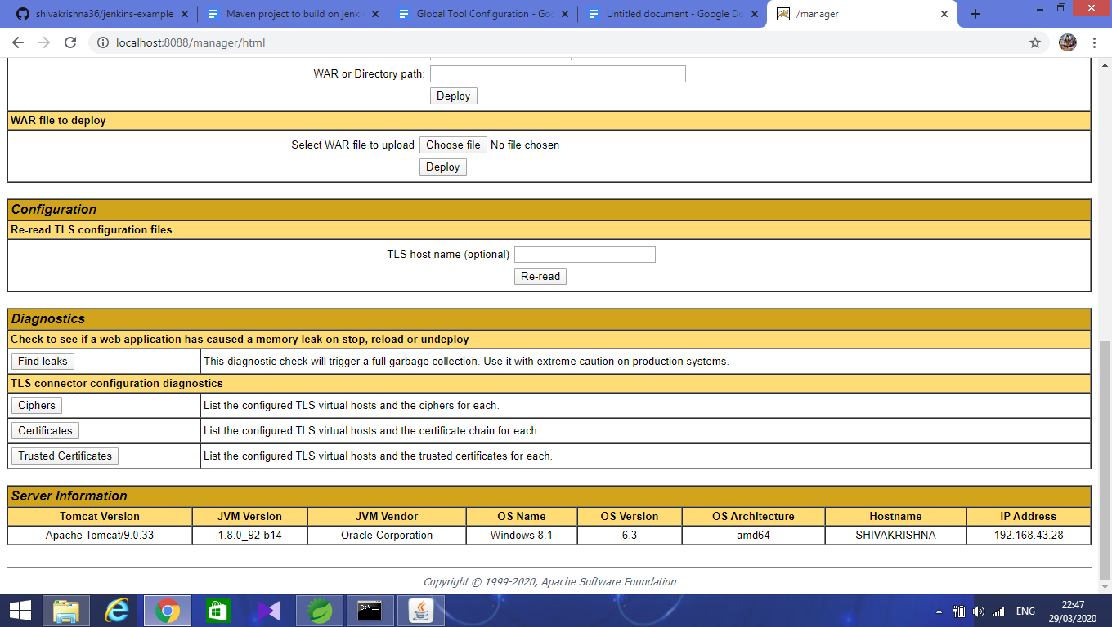

War file is deployed successfully and we can see the message **ok** at the top.

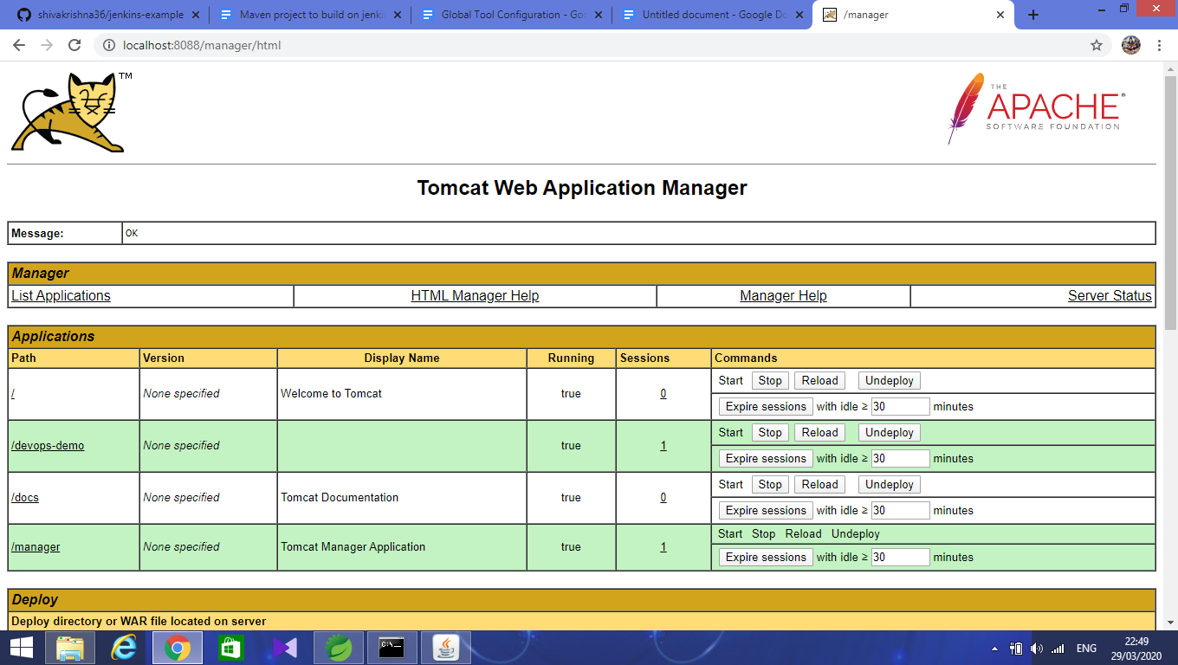

Now click on the file that you have deployed that is under **Applications** that will hit the project home page directly.